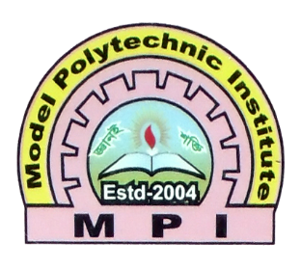

**Remarks**

**Assignment Report**

|  |  |
| --- | --- |
| Subject Name | **:** E-Commerce & CMS |
| Subject Code | **:** 66674 |
| Expt. / Job No | **:** 01 |
| Name of the Expt. / Job | **:** Create & deploy a small E-Commerce websites using CMS, including creating and editing content, adding functionality & creating custom templates & themes based on WordPress/Drupal/Joomla |
| Date of the Expt. / Job | **:** 24-05-2023 |
| Date of the Sub. / Job | **:** 14-06-2023 |

|  |  |  |  |
| --- | --- | --- | --- |
| **Submitted By:** | | **Submitted To:** | |
| Name | : Md. Jahid Hossain | Name | : Ferdows Hasan Sony |
| Department | : Computer | Programmer | **:** CSE |
| Board Roll | : 434575 |  |  |
| Semester | : 7th |  |  |
| Session | : 2019-2020 |  |  |

**MODEL POLYTECHNIC INSTITUTE, JASHORE**